FULLY FUNDED PLACES ON A RESIDENTIAL ARCHITECTURAL DRAWING SUMMER SCHOOL
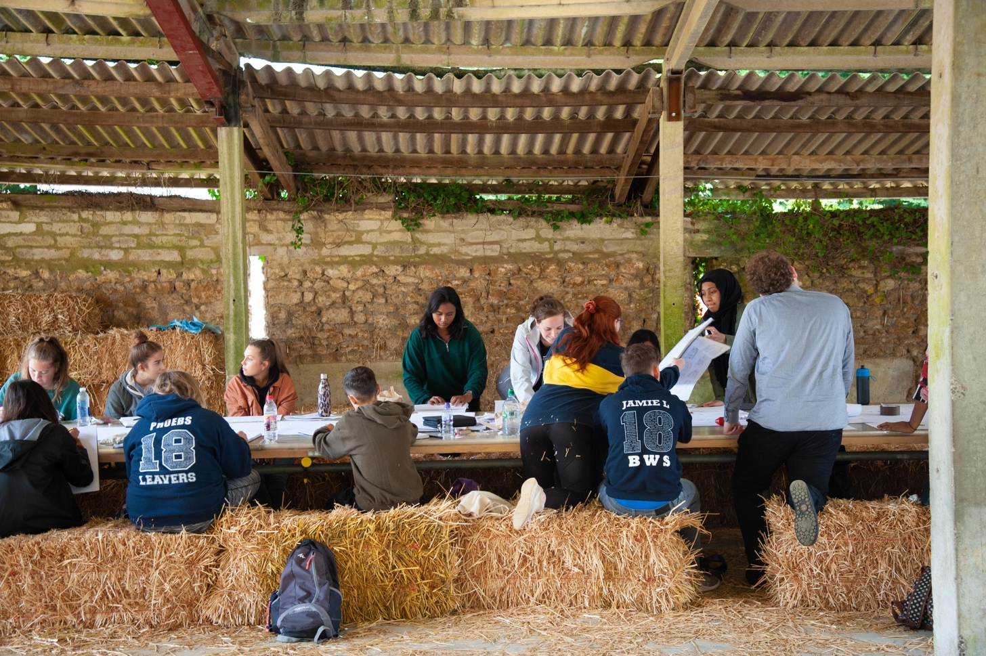
CALL FOR APPLICATIONS

Final week of August 2022

If you are a student in Year 1 or 2 of your A levels and you have an interest in studying architecture this is a great opportunity to learn more about the subject with some of the best lecturers teaching architecture in the UK.

Places are allocated on merit, and are free to successful applicants thanks to our partners and backers, so read on to see how to make use of this unrivalled chance for extended tuition in a fun filled week in Somerset.

ARCHITECTURAL SUMMER SCHOOL, FINAL WEEK OF AUGUST 2022
INVITATION FOR STUDENTS TO APPLY

Dear [School]

I am writing to let you know of a major learning opportunity taking place in Summer 2022, in the form of an architectural summer school to be held in Somerset in the final week of August. You can view a short film of last year’s Summer School at https://vimeo.com/463022881.

The Architectural Drawing Summer School has been offering a unique fully funded opportunity to students since 2016 and has been widely praised by all students as providing an unrivalled insight into architecture and the associated professions. We write now in that you might let students and teachers know and encourage students to apply. We welcome students in Year 1 or 2 of their A levels, and there are no limits per school – we welcome as many applications as there are interested students. We write so that teachers may spread the word amongst their cohorts and encourage students they think might benefit to apply.

We are looking for intelligent and communicative young people with a keen interest in the visual environment, an inquisitive attitude and a positive approach to learning. We particularly welcome
applicants from low income households. Our intention is to give young people an opportunity, at what could be a pivotal point in their intellectual development, an understanding of the built environment and access to insights and skills that are not taught in secondary schools.

During the week students will be exposed to conversations and exercises set by leading thinkers in architectural education today. The programme introduces students to architecture through a wide range of activities including drawing, discussion, practical experimentation and collaborative learning. A key part of the course is the network of contacts they will form with other students, and this conversation acts as a key part of the course, accelerating personal insight and position, in a simulacrum of university life.

Primarily a residential summer school, bed and board is provided by Bruton School for Girls. Workshops take place at Hauser & Wirth Somerset, Drawing Matter and in and around the town of Bruton. Distance learning content will provide opportunities for broader engagement and provide a potential alternative if students are unable to attend in person. Students have had the landscape of their education narrowed due to the pandemic - we present this course as a chance to redress this somewhat.

The Summer School is organised and funded by Drawing Matter (www.drawingmatter.org), Hauser & Wirth Somerset, Kingston School of Art and Bruton School for Girls and has been able to grow thanks to generous sponsorship from leading architects including Eric Parry, Peter Wilson and Niall McLaughlin. Expert tuition is led by Andrew Clancy, Professor of Architecture at Kingston, with a team of tutors from our partner universities including Queens University Belfast, Cardiff University and University of Dundee.

HOW TO APPLY

Applications can be made directly by students or on their behalf by teachers who nominate them. In both cases the process is the same, and can be done by post or email.
Please carefully follow the instructions as the large volume of applications requires it!

BY POST:
Please send to
Prof Andrew Clancy,
Kingston School of Art,
Knights Park Campus,
Kingston upon Thames,
KT1 2QJ

BY EMAIL
Send to a.clancy@kingston.ac.uk
Subject: SUMMER SCHOOL 22 APPLICATION (emails without this exact subject will be missed)

PLEASE INCUDE IN THE APPLICATION THE FOLLOWING:
- A brief (200 words maximum) statement from the pupil describing the aspect of architecture they find most confusing, interesting, intriguing. This is not a trick question; the most honest answers are the best. The student’s name must be included at the head of the text, surname first.
- A maximum of 4 A4 size sheets demonstrating the student’s work – this can be sketches, drawings, models, paintings etc. These can be originals or reproductions as the student sees fit. It should be noted, however, that these entries cannot be returned. Include the students name on every sheet, surname first.
- A completed copy of the Cover Sheet for Entries included on the final page of this letter.

There is likely to be considerable competition for the forty-five places available, so this supporting material will be a key part of the selection process.

Offers of places will be made to nominators by 6 June 2022 and will be conditional on parental/carer consent. Nominators of pupils attending the Summer School will be invited to a concluding exhibition at Hauser & Wirth Somerset, Bruton, (www.hauserwirthsomerset.com/) on the final day of the course.
If you have any questions, please contact me on this email address and I will be happy to help.

Prof Andrew Clancy PhD MRIAI
Kingston School of Art

Cover sheet for Entries to be considered for the Architectural Drawing Summer School
No applications will be considered without this sheet fully completed and attached to submissions.

Name of Applicant

Date of Birth (you must be over 16 at the time of the course) __________

Email address
Mobile number

Parent/carer contact details
Name
Home Postal Address Home Phone number Email address Mobile number School Address Parent/carer signature giving consent to involvement

School Contact details (if recommended by school, not necessary if not)
Name
School Address
School Phone number
Email address

I give my personal data freely for the purpose of applying for and if selected, taking part in the Architectural Drawing Summer School and understand my personal data will only be used for the direct purposes of the organisation and running of the summer school, and follow up requests for feedback etc. and will be destroyed when no longer required.

Applicant (student) signature

Please attach this sheet to your submission.

Successful applicants will be contacted on behalf of Prof Andrew Clancy by Bruton School for Girls by Friday 27th May, when further forms for completion will be sent.

