28

A Collector’s Ethical Responsibilities?
Álvaro Siza’s social housing projects at the Drawing Matter archive

Niall Hobhouse interviewed by Andrew Clancy

[Andrew Clancy] The Drawing Matter collection that Niall Hobhouse has amassed is, in my view, the most significant in privately held hands. This significance is magnified by the way it absorbs and distributes the knowledge in its collection. It is a living place, where the knowledge of architecture, as manifested in a series of drawings and models is subject to a restless interrogation by scholars and students of architecture from all over the world, who make the pilgrimage to Somerset. It is housed in a wonderful building by Hugh Strange.
The conversation we are going to have here is about a pivotal moment, some six years ago, in the formation of that collection―in relation to the acquisition of a substantial quantity of works by Álvaro Siza. Maybe as a way of opening the conversation, Niall, I can ask a simple and provocative question: how does someone like you arrive at the conclusion that Siza is somebody worth investigating and collecting?

[Niall Hobhouse] Can I slightly dodge your question and try to answer it another way, by telling the story of the slow process by which Drawing Matter came to own all the material for the three key social housing projects in Portugal, which were all started by Siza in the early 1970s and ran their course through the years of the Portuguese Revolution and beyond? In this conversation, I am as focused on why these projects, as much as why Siza (Figure 28.1). I should start with what was my first meeting with him.
I had flown to Montreal for a meeting at the Canadian Centre for Architecture; Siza had been there for three or four days, with Carlos Castanheira, his longstanding collaborator, particularly on the recent Asian projects. I was invited to join them both for lunch that first morning, and it was clear that the CCA team―I think they would agree―was a little at a loss as to how to entertain the distinguished visitors on their last afternoon. For reasons of my own, I had wanted to look properly at the Mies van der Rohe drawings in the collection, so I suggested that we go to the library together. Siza brightened; Carlos seemed intrigued.
We spent what turned out to be several hours going through sheet after sheet whilst listening to Siza’s thoughtful commentary. I really think that this story begins by bonding over someone else’s drawings in a way that felt, for me, extraordinarily privileged.
It was also a key moment of a realization that institutions sometimes―I am not only referring to the CCA―can allow themselves to be defeated by the very archival material that they exist to preserve and interpret. Siza’s curiosity and excitement, combined with the kind of knowledge that only an architect can bring to another’s drawings, were the key.
Out of that long afternoon emerged an invitation to go to Portugal and visit his archive. There followed seven or eight trips to Porto, more or less monthly. It was always the same pattern, looking at drawings and models in the archive, which was already beautifully arranged and cataloged. Sometimes, in the afternoons, we would go together to the built projects locally, to which the drawings related. It was a process of exchange and, ultimately, of developing mutual trust. In those early stages, I did not yet know enough about the development of Siza’s architecture―either over his longer career or about the process by which individual projects evolved. For the collection in Somerset, it is the relationship between drawings and architecture that is always central―what the drawings can often reveal that the building cannot, but always moving towards a clearer understanding of the architecture.

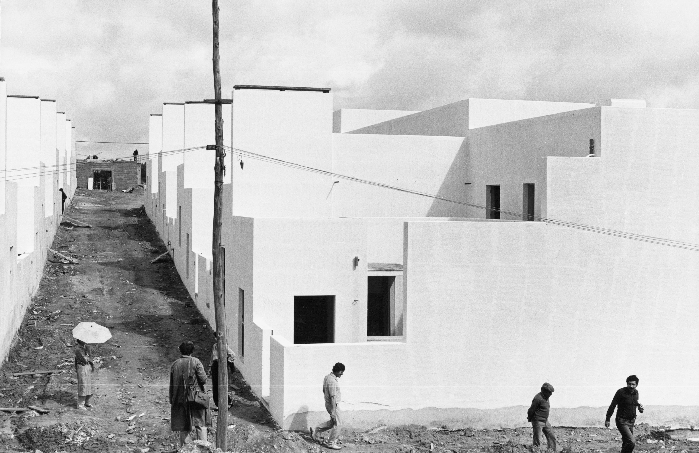
Figure 28.1 Quinta da Malagueira under construction. Photographer unknown. Courtesy of Álvaro Siza.

[AC] It is interesting that when you first arrived at Siza’s office, it was already seen as an archive with some sense of order. Did that include the notebooks, incidental sketches, and biographical material that now form our understanding of that archive through your collection and others?

[NH] The particular occasion for Siza’s invitation was that the various proposals put forward in Portugal, to house his archive as a single body of work, had all dissolved as a result of the financial crisis―this was in 2010–2011, the bleakest moment for Portugal particularly. The invitation to Drawing Matter came because a section of archival material for the SAAL São Victor housing project was then in the process of being acquired by MoMA. The idea of the archive being thoughtfully distributed between different institutions was already something that Álvaro had embraced. (I do remember swapping stories―his own about Távora, mine about Wright and Aalto―of the strange inertia that can overtake institutions assuming sole ownership and control of an architect’s legacy). We were both excited by the opportunities presented by fostering some (gentle!) competition between multiple repositories.
At this point, Siza had not parted with any of his hundreds of notebooks. It emerged very early in our discussion that, for Nicholas Olsberg and me, there was an exciting conjunction between their first use by Siza as a tool for thinking, and the first complex mid-career commissions, conceived at a time of extreme political change in Portugal. The origin of the notebooks seems to have been both somehow in the Revolution itself, but also with the social housing at Bouça and Malagueira; they have continued ever since.

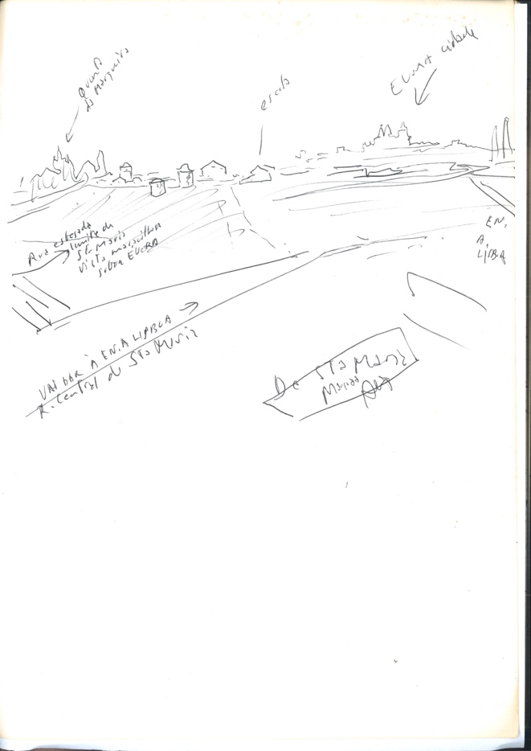
Figure 28.2 Álvaro Siza, study of the Évora skyline, page from ‘caderno 1’, March 1977. Biro on paper, 297 x 210 mm. Courtesy of Drawing Matter Collections. © The architect.

A story I tell very often is that during the early stages of the Malagueira project, he would make site visits every Wednesday, taking the train overnight, the ferry across the river from Lisbon, then another train to get to Évora (Figure 28.2, 28.5); he would work all day, returning overnight by the same route to Porto. When he then stumbles into the office on Thursday morning, there are sketches and notes coming out of every pocket. Eventually, someone in the office goes to the corner stationer and buys a black school exercise book: “Please, Mr. Siza […].”
(A nice coda to this is that half of our Malagueira notebooks are actually bright red, not black―it emerged that the radical Mayor of Évora in those years had decreed that children in the city could only do their work in exercise books that were red).
What I have been saying about the notebooks seems a digression, but you might begin to see how the narrative, to make any sense, really has to dance between drawings and buildings. Besides, the notebooks are at the center of the design work and the acquisition by Drawing Matter of a large part of Álvaro’s archive.
It had been on my third visit to Porto, accompanied by Nicholas, that we made the decision to focus on the large housing projects of the revolutionary years. One part of this interest was, of course, the existence and availability of the notebooks; another was a determination to acquire only complete and seminal projects.

[AC] In 2010, Siza is already a world-famous architect. I suppose the consensus at this point would have been that Boa Nova, the early swimming pool projects, the individual houses, and the banks constituted a thesis and that the masterpiece was created earlier in the career. You have a very strong position—that on observation of the work and process behind the masterpieces were the Malagueira project and the Bouça housing project.
I recently stumbled across a quote from Siza when he was trying to get those projects. His colleague raised a criticism, asking if he could design housing given that all he had designed to date had been bourgeois houses for the middle class. Siza responded that because he had been designing bourgeois houses, he had a unique understanding of the end user and that architects who have been engaged only with social housing understand the end user through an institutional lens. The houses were the apprenticeship for social housing. Was that self-understanding present as you started to explore the collecting of those particular projects? How did Siza respond as your focus narrowed?

[NH] Part of what I went to see in Évora and Porto were the horribly cursory efforts of the Salazar government to build social housing. I was able to understand what a radical shift these buildings for the SAAL, by Siza and others, represented.
I think there were several factors at play in our not asking for any of the earlier material. Those wonderful projects had (though not until the 1980s and 90s) been published to exhaustion―we all knew what they looked like. It was also important not to overly compromise the appeal of Siza’s archive for other eventual suitors, and particularly Portuguese ones, for some or all of the material that remained. And then, it was only with Bouça that Siza began to work at real scale but, within each project, at every scale at once―from door handles to large urban landscapes (Figure 28.3). Besides this, the ambition of the developments at Bouça and Malagueira, the diversity of their stakeholders and, above all, the long periods over which they evolved meant that there were richness and complexity in terms of the archive material itself―sketches, models, working drawings, technical stuff, and of course the notebooks.
I think there was something else that turned out to be important, and that was the realization that this social housing put Siza on the international stage and led directly to the first overseas commissions. That was the moment when Kenneth Frampton first drew international attention to the work, and every left-wing architect in Europe was going to Portugal to examine it.
So, there is an argument that this is not only when Siza realized himself fully as an architect, but also the moment when that perception translated to international recognition. Revolutions make for curious caesuras―as I have spent time in Portugal, I have learnt that there are two narratives of modernism. One is that there was nothing before the events of 1974; the other, mostly from people in the north, traces a very clear lineage through Távora and early Siza. It is a subject of passion and argument in Portugal. I slowly learnt how politically charged these projects were in the national narrative and how, in a sense, each turns on a view of Siza’s work of this period. And then, I think that buildings are always best when the architect holds a passionate idea or belief about their making. This is really a condition of great architecture, and certainly of architectural change. There is no question in my mind that Siza felt that, by reimagining these typologies, he had a chance to change the world in a way that bourgeois housing never can; these were political projects by conviction, not default.

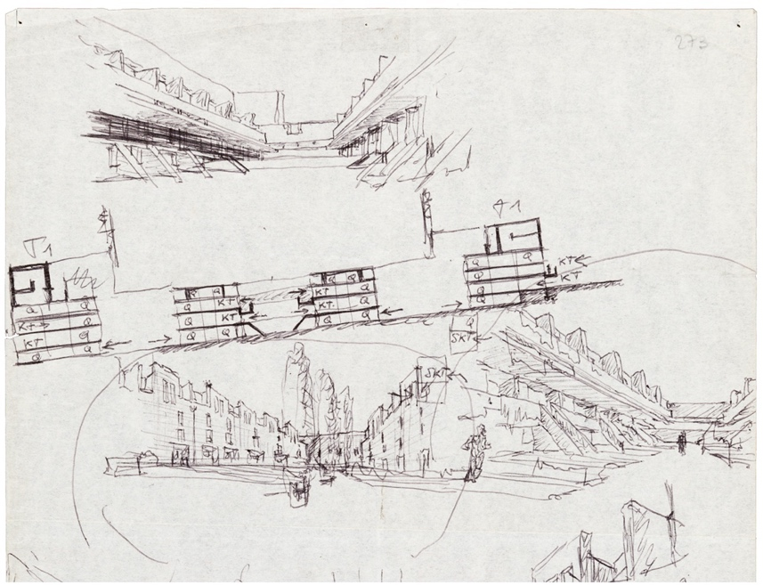
Figure 28.3 Álvaro Siza, section and perspectives of housing blocks, Bouça housing estate, Porto, c. August 26, 1975. Biro on paper, 296 x 208 mm (detail). Courtesy of Drawing Matter Collections. © the architect.

[AC] I understand all that in terms of the external significance of the work, but in terms of being a collector, this was also the moment of the birth of Siza’s notebook practice. It is really interesting that if you go to Shatwell and go through the production drawings from Siza’s office and compare them to the notebooks, you can start to dream the chronology of journeys to and from the office you described earlier. What is remarkable about the notebooks is the interweaving of Siza’s biographical material―intimate drawings of friends and family and social encounters, drawing into other projects, and the project that he is working on. There are plans, but they are in a situated viewpoint: cavalier projection, constantly placing himself within the frame of the drawing. There is a lot of material in the sketchbooks that fleshes out the conventional drawings. I can see why the sketchbooks are part of the attraction.

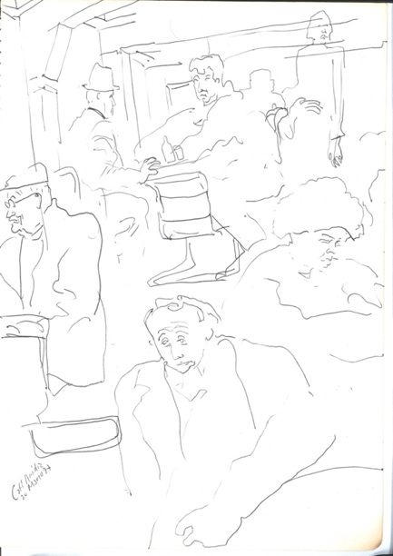
Figure 28.4 Álvaro Siza, sketches of café patrons, Évora, page from ‘caderno 1’, March 1977. Biro on paper, 297 x 210 mm. Courtesy of Drawing Matter Collections. © The architect.

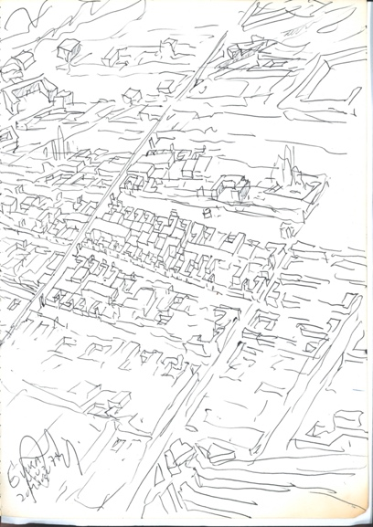
Figure 28.5 Álvaro Siza, city plan of Évora, page from ‘caderno 1’, March 1977. Biro on paper, 297 x 210 mm. Courtesy of Drawing Matter Collections. © The architect.

[NH] Yes. I sometimes say to students that they should look at the notebooks as ninety-nine pages of mistakes; I hope they find this reassuring.
There are some very lovely sequences of pages where he is drawing again and again, and again, let us say, a courtyard view of one of the houses in Malagueira. Eventually, after what has clearly been a two-hour session, he puts a ring around what is then a final version. But, two days later, he starts again, and it is no longer the final version but the beginning of a new sequence.
Our agreement, when we asked for the sketchbooks as part of the acquisition of all the material for the early Portuguese housing projects―Álvaro needed to think about whether he wanted to part with them―was that he was free to edit them of any personal information. For example, if he had seen a pretty girl on the train and done a doodle, or a sketch of friends at a dinner party, he was free to rip it out and keep it. In the event, I think he could not quite bring himself to destroy the integrity of the document, and I was touched that he did not (Figure 28.4).
In a way, this is a story against ourselves―we were curating an exhibition in Berlin, and were interested in finding ways to properly articulate the practice in the notebooks. I had been set upon by my friends and rivals in museums, who always tell me that bound drawings are a frustration because no more than one page at a time can ever be displayed, and that (more darkly) in any case they surely present problems of conservation.
Manuel Montenegro and I hit on an idea that I would fly to Porto one Sunday morning with seven of the early notebooks. We found a local film crew, who put a camera above Siza’s head, and an ashtray beside him; for four hours―incredibly generous on his part―he went through the notebooks page by page and, for all of us there, the experience began to have something of the vividness and the immediacy that it had for Álvaro himself, as he had drawn in them forty years before (Figure 28.6).
We cut the film carefully and persuaded our partners in Berlin to open the display cases and turn the pages every three days so that in the film, Siza was always talking directly to the images being shown. Manuel was writing a PhD, which included studies of the early collaborations with Távora, and it emerged twenty minutes into the discussion that he was using the interview with Álvaro to get him to confirm, on camera, the fundamentals of the thesis. He succeeded so well at this because the books preserve the sequence of daily thought, as the architect moves quickly between whatever projects are current. I remember that there was one tentative study for the end of the Bouça building ranges that had a very particular form. Siza turned the page, and the same form appeared again but adapted to one of the projects for a bank building. At this, Manuel says, “I begin to wonder if the idea of you being a contextualist really holds up in relation to your work?” and Siza replies, “Me, a contextualist? Never […],” and we caught a glimpse of how Frampton must have appeared when viewed, as it were, from the regions.

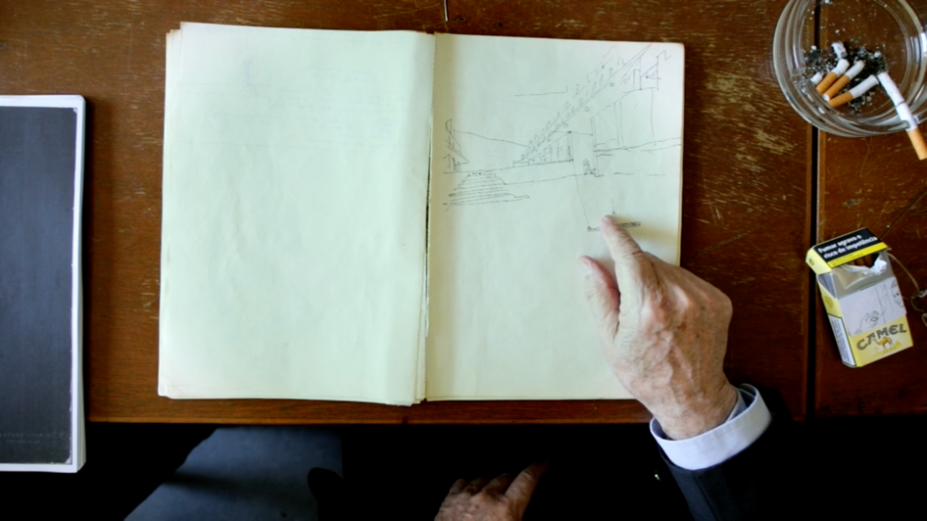
Figure 28.6 Still from Álvaro Siza: Seven Early Sketchbooks, 2018. Courtesy of Drawing Matter. © Drawing Matter.

[AC] The notebooks are among the most electrifying things for students who might never have heard of Siza because of the way they convey the humanity of the architect. They open up those conversations where we can explain that, fundamentally, the architect should be looking at the drawing with a sense of inadequacy. If you care about the building at the end, the drawings (and I know we are in a room where we might prioritize the drawings) are always a disappointment because they are merely a route to the building. Siza’s drawings make that explicit. The mirroring of his thought processes on such an intimate level, the way they have been excavated, and talked about: is there any feedback from Siza as to how he receives all of that? Does he welcome or reject it?

[NH] Initially, there was a sense of unease. In our discussions, it had not occurred to him that the notebooks should be part of his “legacy” archive. Now that we have energetically incorporated them into the collection, he has been happily co-opted into our projects as a collaborator. Tony Fretton told me that seeing the Siza books obliged him to think again about his own drawing practices in relation to his own early work. In this way, the impact of their arrival has been profound, both on the collection at Shatwell and, as important, on what we do with it.

[AC] Your collection has several architects who drew notebooks not as a private investigation but conscious of the future eye over their shoulder. Siza’s sketchbooks do not feel like they are in that camp.

[NH] There is nobody else there when he is drawing.

[AC] Yes, it is nobody but Siza looking at those drawings. It is an intimate place, unlike others in the collection that look like supporting pieces. I am curious about this self-aware position by the practitioner―this is beyond Siza now―a false intimacy as a deeper truth.

[NH] Or maybe, however intimate in their beginnings, they have become another kind of tool for addressing a different audience. We have presentation booklets for Chandigarh into which Le Corbusier has incorporated pages from the sketchbooks, which one experiences, uneasily, as direct speech from the master.
Just to go back to Malagueira (and to give critical regionalism its due as part of the wider discourse at which it was really aimed), one must say that this moment in Portugal, the mid-Seventies, coincides in America with the explosion of architecture as an autonomous discipline, often on paper, and with the glorious early years of post-modernism. Without dismissing for a moment that intellectual foment―I love our material by Graves and Eisenman―we can see that the Siza notebooks have an integrity of a very different kind―a great architect making his buildings without self-consciousness, just through a process of drawing, and redrawing. There is no ambiguity about the utility and ephemerality of the drawings.
Strangely, to understand a Siza notebook simply as a utensil makes it much more precious―to Drawing Matter at least!

References

Frampton. Kenneth. 2006. Álvaro Siza: Complete Works. London: Phaidon Press.
Frampton. Kenneth. 2018. Álvaro Siza Vieira. A Pool in the Sea. New York: Actar Publishers.
Luscombe, Desley, Helen Thomas and Niall Hobhouse, eds. 2019. Architecture Through Drawing. London: Lund Humphries.
Montenegro, Manuel. Forthcoming. “The School of Porto. Engaged criticality and agonism, between participation and authority, since ’74.” PhD Dissertation working title. Zürich: ETH Zürich, Department of Architecture.
Siza, Álvaro. 1986. Álvaro Siza: Poetic Profession. Edited by Kenneth Frampton. Milano, New York: Electa, Rizzoli.
Siza, Álvaro. “Álvaro Siza: Drawn Closer.” June 11, 2020. https://drawingmatter.org/alvaro-siza-drawn-closer/, accessed November 7, 2020.
Wang, Wilfried and José Paulo dos Santos. 1988. Álvaro Siza: Figures and Configurations, Buildings and Projects, 1986-1988. New York and Harvard: Rizzoli, Harvard GSD.

This interview took place as part of an invited event at the Frascari Symposium IV, The Secret Lives of Architectural Drawings and Models: From Translating to Archiving, Collecting, and Displaying, which took place at the Kingston School of Art, Department of Architecture and Landscape, June 27-28, 2019.
https://www.drawingmatter.org, accessed November 7, 2020, accessed December 4, 2020. See Chapter 13, in this book by Sophia Banou on the Drawing Matter archive in Somerset, UK.
Fundação Calouste Gulbenkian, Lisbon, Portugal, https://gulbenkian.pt/noticias/acesso-online-ao-arquivo-alvaro-siza/; Serralves Museum of Contemporary Art, https://www.serralves.pt/en/ciclo-serralves/1909-alvaro-siza-in-disciplina/#false; CCA, Montreal, Canada: https://www.cca.qc.ca/en/search/details/collection/object/447183, accessed November 7, 2020.
See https://www.moma.org/artists/29732#works, accessed November 7, 2020. The São Victor housing complex in Porto was developed in 1974-1977 for the Serviço de Apoio Ambulatório Local (SAAL).
The archive of Fernando Távora (1923-2005) is at the Marques da Silva Foundation Institute (FIMS), Porto. See Chapter 29 by Neil Levine in this book, on the transfer of the Frank Lloyd Wright archive (1867-1959) from the Taliesin Fellowship (Taliesin West, Scottsdale, Arizona), to the Avery Architectural & Fine Arts Library at Columbia University and MoMA in New York. See also Chapter 36 in this book by Janet Parks who curated the transfer of the Frank Lloyd Wright’s archive.
The Bouça project was designed (1975-1976) and built (1977-1978) in Porto. The Malagueira project in Évora was developed between 1973-1977.
Siza, June 11, 2020.
Frampton 2018: 72.
Siza 1986. Wang and dos Santos 1988. Frampton 2006.
Siza 1986. Frampton 2006.
Manuel Montenegro has identified that on the verso of this sheet is a calendar of events from August 26, 1975 to January 1976. The calendar, and annotations at the bottom of the sheet, suggest that this is one of the first (if not the first) drawings that Siza made to restart the Bouça project within the context of SAAL.
Opening Lines. Sketchbooks of Ten Modern Architects. June 30 - October 7, 2018. Tchoban Fuondation – Museum for Architectural Drawing, Berlin, Germany. See the press release of the exhibition: http://www.tchoban-foundation.de/files/press_release_opening_lines_sketchbooks_of_ten_modern_architects.pdf, accessed November 7, 2020.
Montenegro 2017.
https://drawingmatter.org/architect/fretton-tony/, accessed November 7, 2020.

